***Data visualization***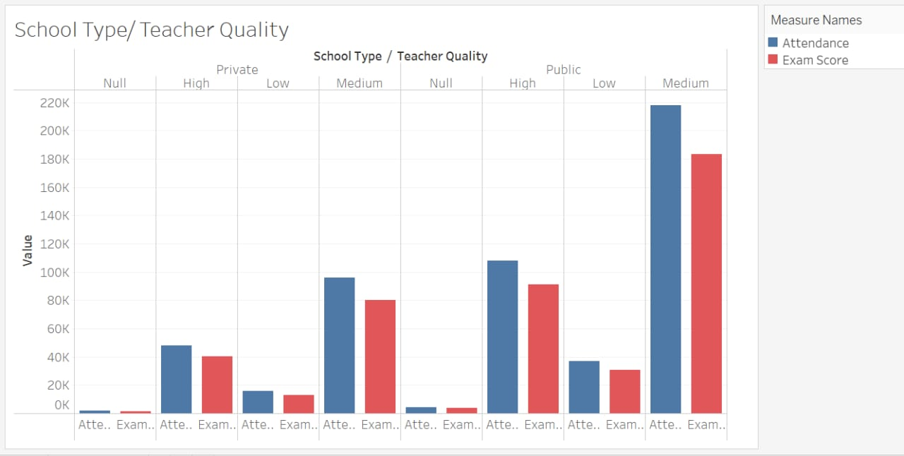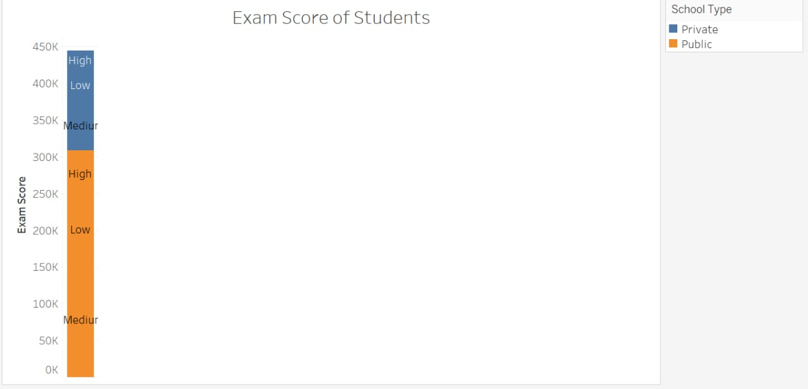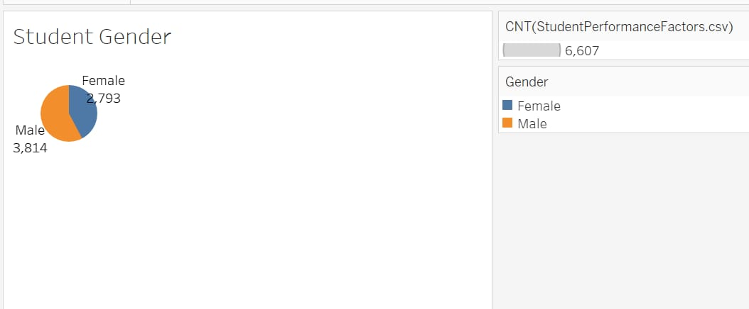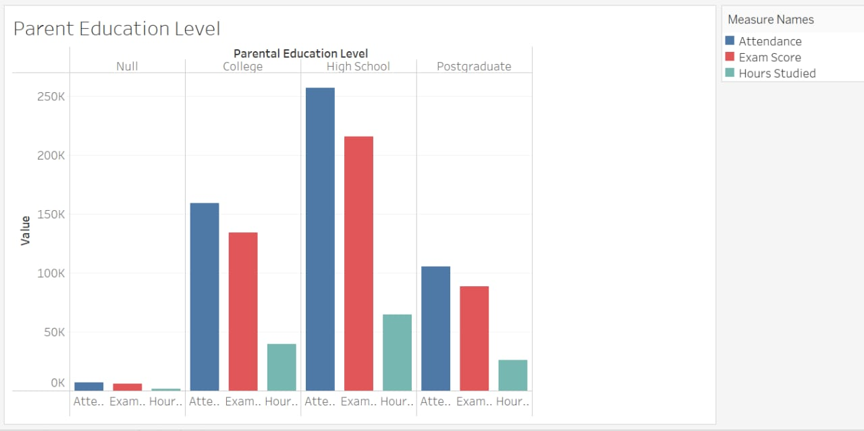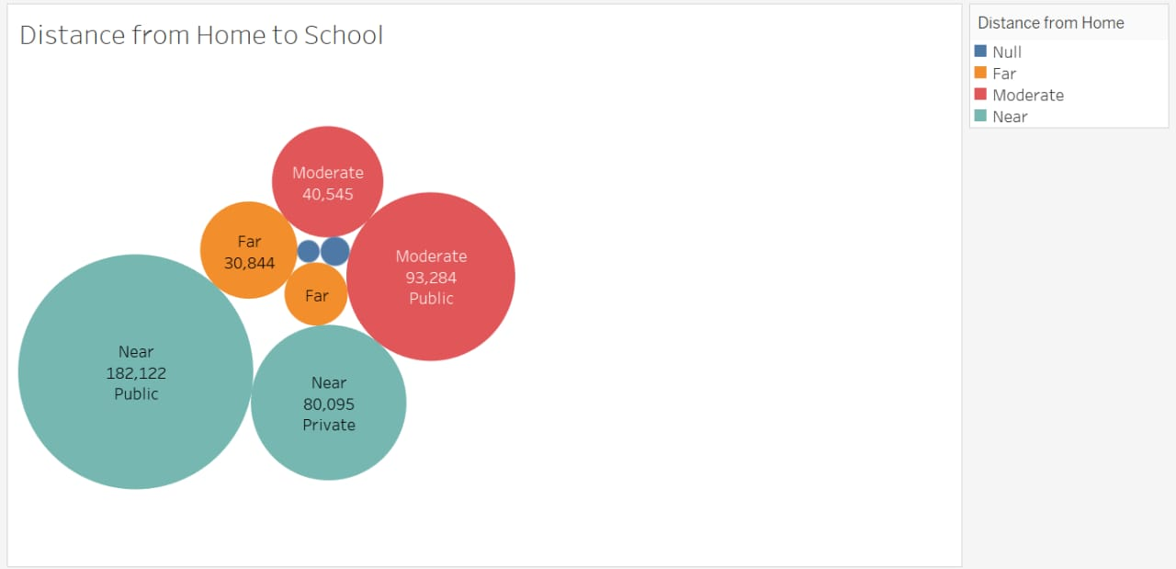x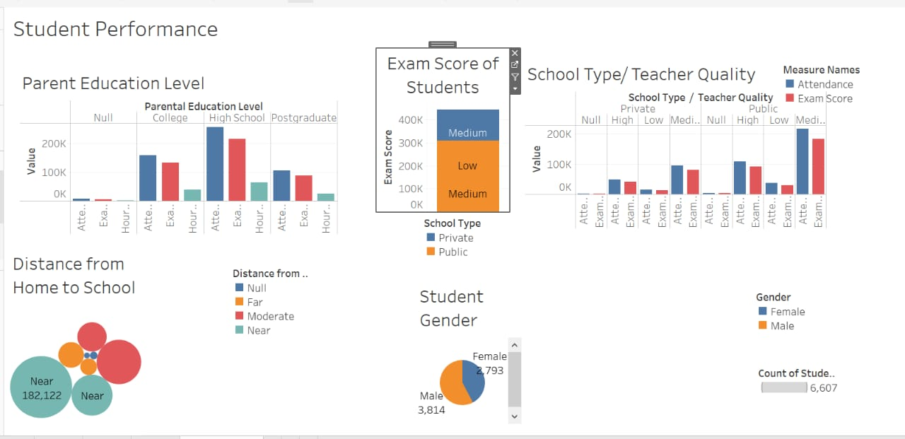

The visualization shows that students with higher parental education levels tend to have higher exam scores, regardless of school type or teacher quality. However, students from private schools consistently outperform those from public schools, regardless of parental education level or distance from home to school. Gender also plays a role, with male students outperforming female students in most categories.outperform those from public schools, regardless of parental education level or distance from home to school. Gender also plays a role, with male students outperforming female students in most categories.